Alice Jane (Somers) Ginter
July 22, 1858 – February 4, 1936

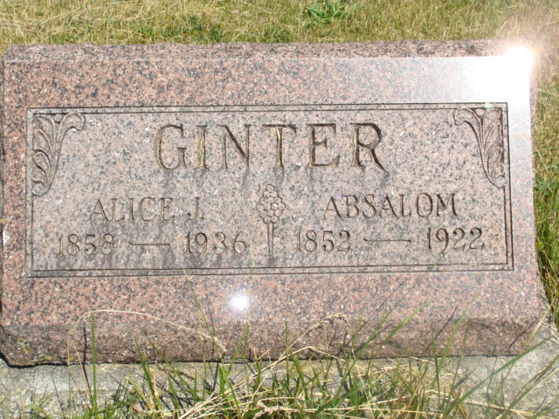
Photo by Alicia Kneuss

Alice Jane Ginter
in the Indiana, Death Certificates, 1899-2011
Name: Alice Jane Ginter
[Alice Jane Somers]
Gender: Female
Race: White
Age: 77
Marital status: Widow
Birth Date: 22 Jul 1858
Birth Place: Wells Co
Death Date: 4 Feb 1936
Death Place: Craigville, Wells, Indiana, USA
Father: Joseph Somers
Mother: Victoria Somers
Spouse: Absalom Ginter
Informant: Homer Ginter; Decatur, Ind.
Burial: Feb. 7, 1936; Antioch Cemetery

