Absolom Ginter
March 24, 1852 – September 8, 1922

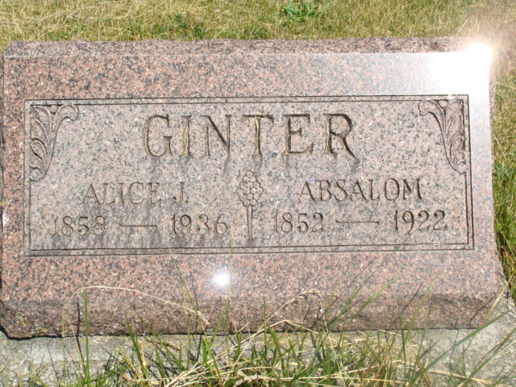
Photo by Alicia Kneuss

AGED FARMER DIED IN FIELD
Absolone Ginter Found Dead In Corn Field Near Monroe This Morning

Monroe, Sept. 8 - (Special to the Daily Democrat) –

Absolone Ginter, aged 70 years, was found in a corn field on the James A. Hendricks farm, one half mile north of Monroe, by his son-in-law, Jesse Johnson, at 11 o'clock this morning. Death is believed to have been caused by heat prostration and heart trouble.
Mr. Ginter went to the corn field this morning to cut fodder. When he did not return to the house for dinner, his relatives became anxious about him, knowing that he had suffered much trouble with his heart last week and Mr. Johnson went to the field to look for his father-in-law.
The deceased is survived by his wife, two daughters and two sons. The children are: Mrs. Charles Hinchon, of Craigville; Mrs. Jesse Johnson, of Monroe; Harve Ginter of Craigville and Homer Ginter of Craigville. No funeral arrangements have been made.

Decatur Daily Democrat, Adams County, Indiana
Friday, September 8, 1922
*****
FARMERS DEATH CAUSED BY HEAT
Coroner Mattax Makes Report in Death of Absolone Ginter

A report made by Dr. L. L. Mattax of Geneva, county coroner, who investigated the sudden death of Mr. Absolone Ginter yesterday forenoon states that death was due to an inter-cranial hemorrhage caused by extreme heat. In the opinion of Dr. Mattax, death occurred about 9 o'clock yesterday morning. His body was found in a corn field where he had been cutting corn, by his son-in-law, Jesse Johnson, about 11 o'clock.
Funeral services will be held from the home on the James A. Hendricks farm, one-half mile north of Monroe at 1:30 o'clock Sunday afternoon. Burial will be held in the Beery Cemetery.

Decatur Daily Democrat, Adams County, Indiana
Saturday, Sept. 9, 1922
*****
Indiana, Death Certificates, 1899-2011
Name: Ebsalom Ginter
Gender: Male
Race: White
Age: 70
Marital status: Married
Birth Date: 24 Mar 1852
Birth Place: Ohio
Death Date: 8 Sep 1922
Death Place: Adams, Indiana, USA
Father: Jacob Ginter
Mother: Sarrah ??owly
Spouse: Alice
Informant: ?? Ginter, Decatur, Ind.
Burial: Sept. 10, 1922; Antioch Cemetery

