Franklin N. Gault
August 22, 1887 – November 2, 1915

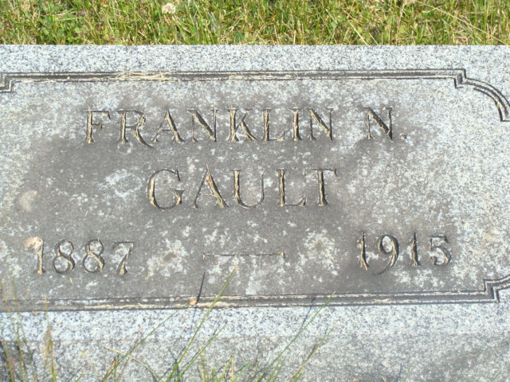
Photo by Alicia Kneuss

Franklin N., son of Dayton and Mary Gault, was born Aug 22, 1887, on the home farm near Peterson, Ind., Kirkland township, and died at the same place, Tuesday, Nov. 2, 1915, aged 28 years, 2 months and ten days.
He leaves to mourn his loss besides the sorrowing parents, one brother and four sisters. They are: William of Preble, Ind.; Nettie, wife of Frank Aurand of Decatur, Ind.; Elizabeth, wife of Everin (sic) Elzy, of Celina, Ohio; Eva and Frances at home. One sister, Bertha, preceded him in death. He also leaves a host of other relatives and friends and neighbors.
Frank was a general favorite among the young people of his community, and will be sorely missed by them. He was a kind and loving brother and dutiful son. Although sorely afflicted, he was very patient, always cheerful and uncomplaining. He had a cheerful word and sunny smile for all, and would tell those who came in to see him that he wanted to meet them in heaven. A few weeks ago he sought and found Jesus, very precious to his soul. He was ready and anxious to go, being perfectly reconciled to God's will. He gained the victory over death by trusting Jesus and died with a shout of glory in his soul and a smile on his face. The end came peacefully, simply falling asleep in the arms of Jesus. "Blessed are the dead that die in the Lord."

Contributed by Lynn Sewell – no name of newspaper or date

