John B. Burkhead
November 11, 1831 – July 25, 1894

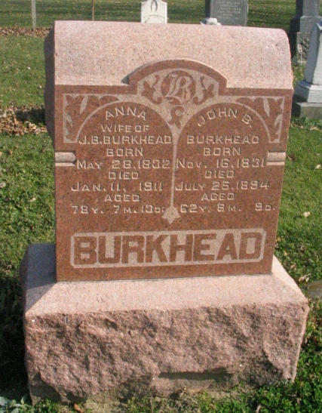
Photo by Barbara Baker Anderson

John Burkhead, who has been confined to his bed for some time past with rheumatism and heart trouble died at his residence last night.
Funeral tomorrow at 10 o'clock at the Beery Church.

Decatur Daily Democrat, Adams County, Indiana
Friday, July 27, 1894

