Anna (Dyarman) Burkhead
May 28, 1832 – January 11, 1911

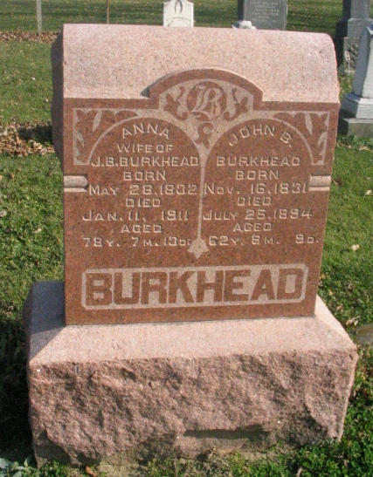
Photo by Barbara Baker Anderson

PIONEER IS DEAD - Mrs. John Burkhead, One of Aged Ladies of County,
Died At 12:40 This Morning At Home of Daughter, Mrs. J. W. Johnson, Near the Washington Church

Anna, widow of John Burkhead, one of the pioneer ladies of the county, passed away this morning at 12:40 o'clock at the home of her daughter, Mrs. J. W. Johnson, neat the Washington Church, southwest of this city, where she had been making her home the past seven or eight years. Mrs. Burkhead had been a sufferer from heart trouble and complications for eight or nine years. Owing to the nature of her disease she was not able to lie down, and practically was never bedfast, though her condition was bad enough to warrant it.
Had Mrs. Burkhead lived until next May 28th, she would have been seventy-nine years of age. Her maiden name was Anna Dyarman and she was born near Newark, Ohio, May 28, 1833. She was married in 1852 to John Burkhead, who has preceded her in death a number of years. She is survived by the following children; Mahalaleel Burkhead of this city, Mrs. Jacob W. Johnson of southwest of this city, Mrs. Chris Geery of southwest of the city, Mrs. Mary Burr of Portland, Mrs. Drusilla E. Miller of Los Angeles, Ca., Frank Burkhead of Hardinsville, Ill, Joshua, a son, died in infancy. She also leaves to mourn her death one sister, Mrs. James Johnson of Monroe; also four halfbrothers -Abe, Dave, Isaac and George DeBolt, and one half sister, Mrs. Catherine Carpenter of Middlebury, Ohio.
The deceased was a very estimable lady and the greater part of her life has been spent here. Two years after their marriage, Mr. and Mrs Burkhead moved to Illinois to reside and then returned here where the rest of their lives have been spent. Mrs. Burkhead resided in this city about eighteen years.
The funeral will be held some time Friday at the Beery Church, though the exact time has not been set pending word from the son, Frank, of Hardinsville, Ill.
LATER - The funeral will be held Friday morning at 10:30 o'clock at the Beery Church and burial will take place in the Beery Cemetery. The procession will leave the house at 9:30 o'clock.

Contributed by Marge Counterman (no name or date of newspaper)

Abstract gives death date as 1/11/1911

