William B. Brown
September 19, 1810 – February 16, 1878

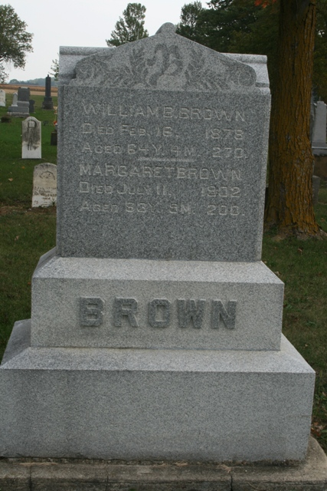
Photos by Jacquie Eisenhut

No obit found at this time

