Rebecca Jane (Cochran) Brown
June 27, 1845 – December 16, 1920

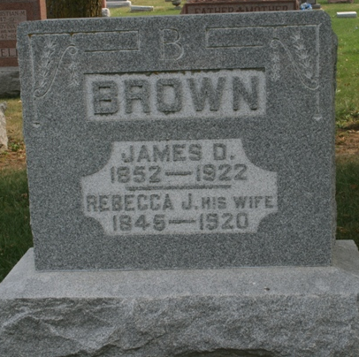
Photos by Jacquie Eisenhut
DIED EARLY TODAY
Mrs. James D. Brown Passed Away This Morning after Long Suffering
FUNERAL SATURDAY
at Beery Church - Husband, Three Children and One Brother Survive

Death came as a great relief this morning at 7 o'clock to Mrs. Rebecca Jane Brown, wife of James D. Brown, living three miles south of Peterson. The deceased suffered from a cancer and since early last spring her condition had grown worse, and her death this morning was no surprise to her family and friends.
Rebecca Jane Cochran was a daughter of John R. and Sarah Ann Mills Cochran and was born in Coshocton County, Ohio, June 27, 1845, making her age seventy-five years, five months and nineteen days. She came to this county many years ago, and with her husband had lived just south of Peterson for the past several years.
Surviving besides the husband are three children, Mrs. Gus Yake, Mrs. Orvil Heller and John Brown, all living in the same neighborhood with the parents. There are also three grandchildren, Verea, Vearl and John Heller. One brother, Samuel Yake [sic], lives in Seattle, Wash.
Funeral services will be held Saturday afternoon, leaving the home at 1:30 o'clock, and from the Beery Cchurch at 2 o'clock. Rev. C. T. Payne will officiate at the service and burial will be in the church cemetery.
*****

Indiana, Death Certificates, 1899-2011
Name: Rebeca Jane Brown [Rebeca James Cochran]
Gender: Female; Race: White; Age: 75; Marital status: Married
Birth Date: 27 June 1845; Birth Place: Cochaton Co Ohio
Death Date: 16 Dec 1920; Death Place: Knoland, Adams, Indiana, USA
Father: John R Cochran; Mother: Sarah Ann Mills
Spouse: James D Brown; Informant: James D. Brown; Monroe, Ind.
Burial: Dec. 18, 1920; Beery Cemetery

