Mariah Elizabeth Brown
December 9, 1849 – September 5, 1924

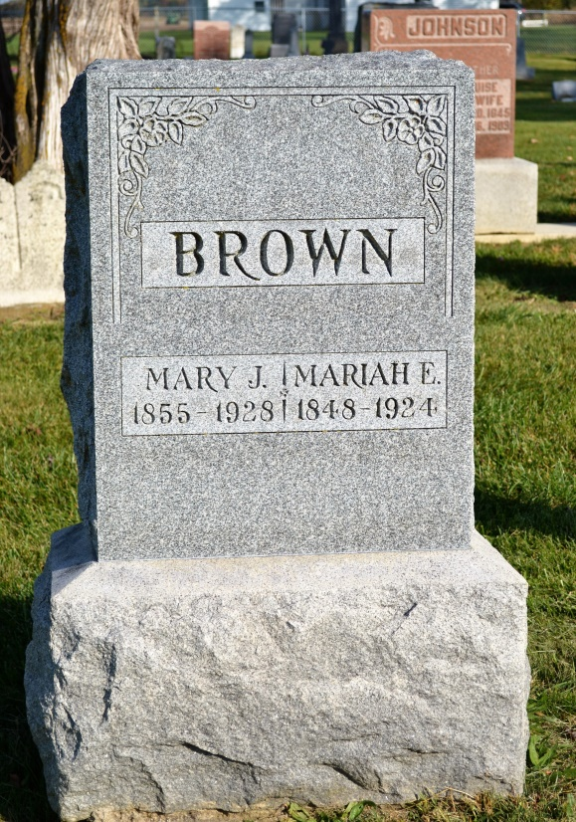
Photos by Colleen Sanders Broyles

Mariah E Brown
in the Indiana, Death Certificates, 1899-2011
Name: Mariah E Brown
Gender: Female
Race: White
Age: 74
Marital status: Single
Birth Date: 9 Dec 1849
Birth Place: Indiana
Death Date: 5 Sep 1924
Death Place: Peterson, Adams, Indiana, USA
Father: William Brown
Mother: Margaret Barnhart
Informant: J. W. Brown, Sr., Peterson, Ind.
Burial: Sept. 8, 1924; Antioch Cemetery

