Mary A. Bright
August 17, 1859 – October 23, 1880

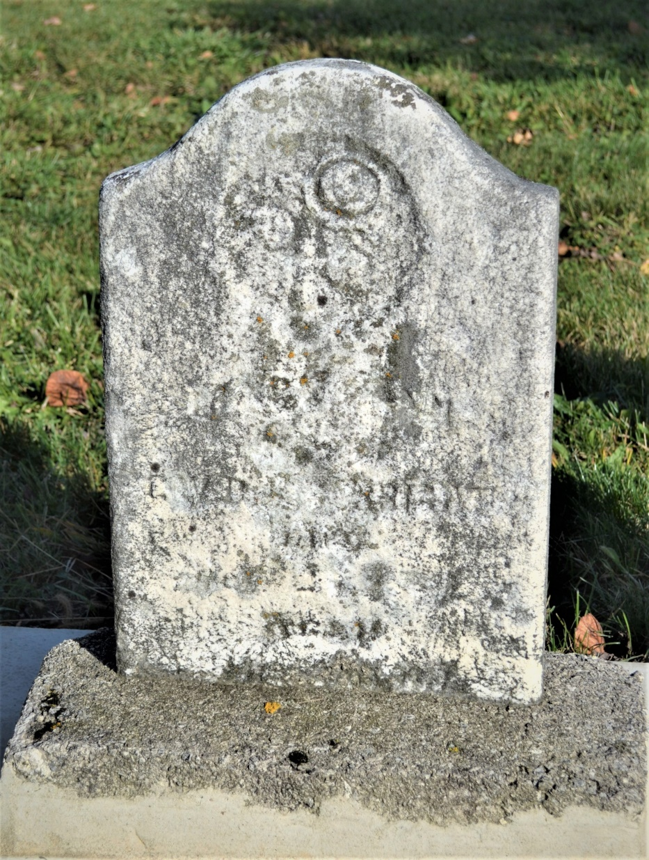
Photos by Colleen Sanders Broyles

No obit found at this time

