Virgene L. (Bierberich) Bowers
January – November 23, 2008

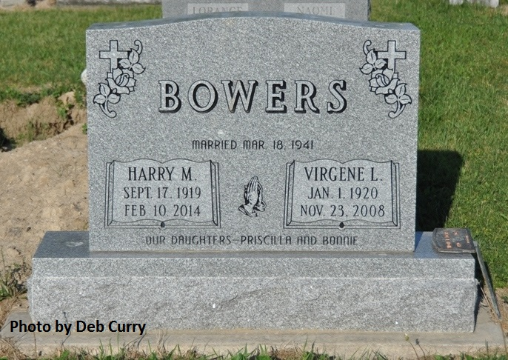

Virgene L. Bowers, 88, of Decatur passed away Sunday, November 23, 2008 at Adams Memorial Hospital. She was born on January 1, 1920 to Lorance D. and Naomi F. (Arnold) Bierberich in Adams County, Indiana. On March 18, 1941 Virgene married Harry M. Bowers.
Virgene was a member of Zion Lutheran Church and the Happy Homemakers in Washington Township. She was a homemaker and also worked at Fort Wayne Wire Die.
She is survived by her Husband Harry M. Bowers of Decatur, 2 Daughters, Mrs. Roger (Priscilla J.) Pyle of Rockford, OH, Mrs. Steve (Bonnie J.) Johnson of Decatur, 1 Brother, Roy (Phyliss) Bieberich of Decatur, 2 Sisters, Mrs. Richard (Helen) Conrad of Decatur, Mrs. Edward (Marjorie) Walters of Maben, MS., 6 Grandchildren and 10 Great Grandchildren. Virgene was preceded in death by 2 Sisters Evelyn and Marie Bieberich.
Visitation will be on Tuesday November 25, 2008 from 2-8pm at Haggard & Sefton Funeral Home. Funeral services will be on Wednesday November 26th with a 9:30am Prayer Service at Haggard & Sefton Funeral Home officiated by Pastor Dan York, followed by a 10:30 am Service at Zion Lutheran Church officiated by Pastor Daniel Gadbaw. Burial will be at Beery Cemetery in rural Decatur, IN.
Memorial Contributions may be made to Zion Lutheran Church.

Haggard & Sefton Funeral Home, Decatur, Indiana, online obits (accessed 8/10/10)

