Lydia (Spade) Bowers
December 24, 1831 – March 2, 1910

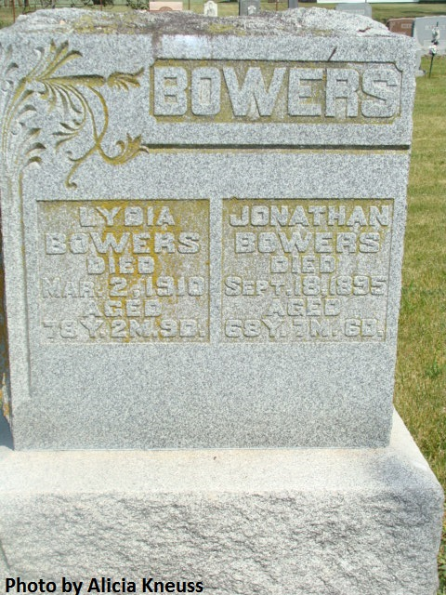

Mrs. Lydia Bowers Dead at Peterson

Decatur, Ind., March 2 - Mrs. Lydia Bowers, aged seventy-eight years, a resident of this county for forty years, passed away this morning at 8 o’clock at her home near Peterson, where she lived with her son Simeon. She had been sick a week with the grip, which developed into pneumonia. She was married January 13, 1850, to Jonathan Bowers, to whom were born twelve children. Mr. Bowers passed away several years ago, but she is survived by six children: Mrs. Oliver Jackson, Mrs. John Thompson, of this city; George, in the Philippine Islands; Mrs. Cassidy, at Hammond; Joseph in Arizona, and Simeon. The funeral will be held Friday afternoon at 1 o’clock at the Reformed Church, the Rev. Snyder officiating.

Journal-Gazette, Allen County, IN; March 3, 1910, Page 9

Contributed by Jim Cox
*****

PIONEER WOMAN DEAD
Death at Petersburg of Mrs. Lydia Bowers

DECATUR, Ind. March 3 - Mrs. Lydia Bowers, aged 78 years, one of the well known residents of the county, died yesterday at her home in Petersburg after an illness of a week from grip, which gradually became worse, developing into pleuro-pneumonia. She had been a resident of Peterson for nearly forty years, coming there from Piqua county, Ohio. The funeral services will be held from the German Reformed church at 1 o'clock Friday, with the Rev. Schneider in charge. Interment will also be made at that place.

Fort Wayne Sentinel, Allen County, Indiana; March 9, 1910

Contributed by Karin King

