Florine N. Bowers
June 13, 1909 – September 8, 1909

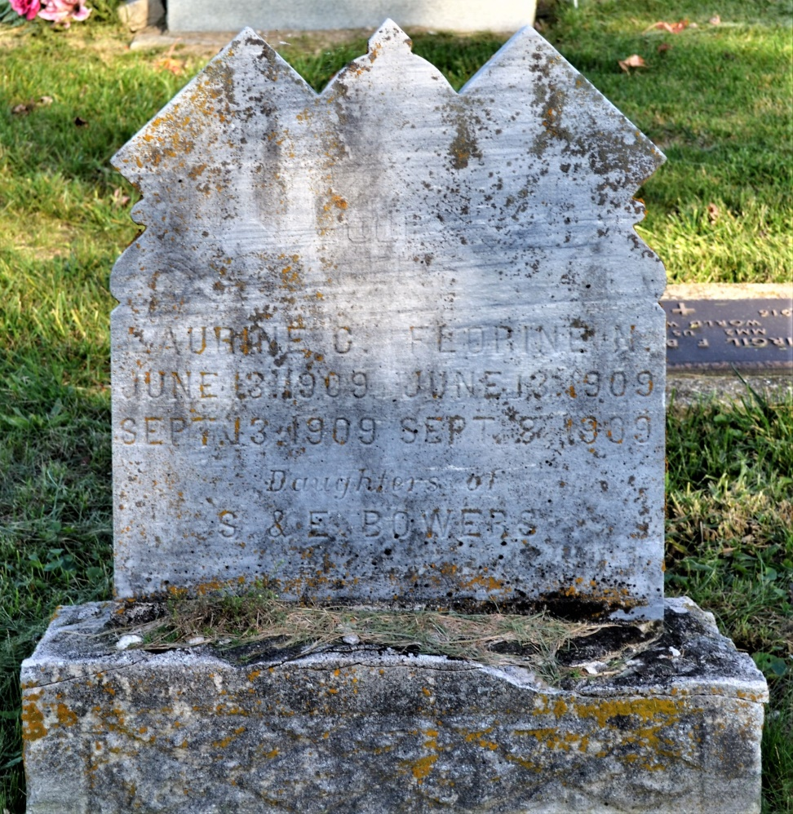
Photo by Colleen Sanders Broyles

Naoma Flonnie Beurer
in the Indiana, Death Certificates, 1899-2011
Name: Naoma Florine Bauers
Gender: Female
Race: White
Age: 2 months, 26 days
Birth Date: 13 Jun 1909
Birth Place: Indiana
Death Date: 8 Sep 1909; Cholera Infantum
Death Place: Kirkland, Adams, Indiana, USA
Father: Simon J. Bauers
Mother: Effie Schackley
Burial: Sept. 9, 1909; Antioch

