Robert Beery
December 22, 1922 – April 19, 2003

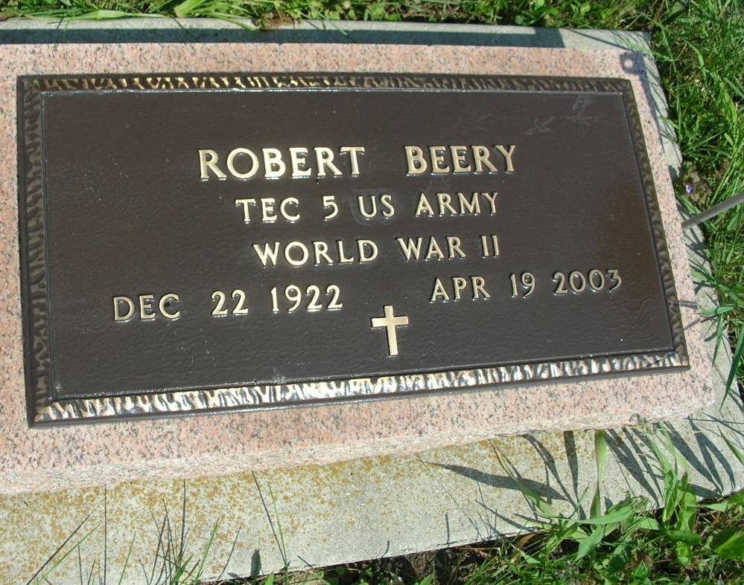

ROBERT BEERY, 80, of Decatur, died Saturday, April 19, 2003 at his residence. Born Dec. 22, 1922 in Adams County, he retired from Central Soya Research Farm in 1982 and was a greeter at the Decatur Wal-Mart for six years. He served in the U.S. Army during World War II. Surviving are his wife, Waunetta "Pinkie" Beery of Decatur; sons, Greg Beery and wife, Linda, of Decatur and Jeff Beery of Milwaukee, Wis.; brothers, Donald and James Beery, both of Decatur; a sister, Patricia Luginbill of Decatur; two grandchildren, Shawn & Tony Beery, both of Decatur. He was preceded in death by his parents, Clyde and Esther (Schrank) Beery, a brother, Bill Beery, and two sisters, Jeanette Lopshire and Virginia Povelich. Service at 1 p.m. Wednesday at Haggard & Sefton Funeral Home, Decatur. Visitation is from 3 to 8 p.m. Tuesday at the funeral home. Burial at Beery Cemetery, Decatur. Memorials to Hospice of Northeast Indiana or American Legion Post 43 Color Guard. To light a candle, click on www.haggardandsefton.com.

News-Sentinel, The (Fort Wayne, IN) - Monday, April 21, 2003

Contributed by Jane Edson

