Reuben Beery
January 10, 1848 – January 26, 1924

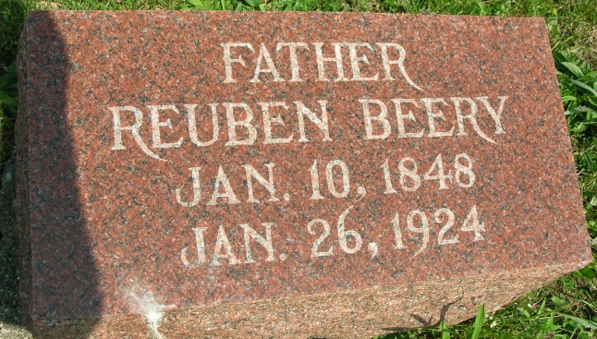
Photo by JC
PETERSON RESIDENT DIES OF APOPLEXY
Reuben Beery Stricken Saturday and Fell Dead at Decatur Hospital
Reuben Beery, 76, life-long resident of Adams County, died suddenly at the Decatur Hospital Saturday, when stricken with apoplexy. Mr. Beery, who resided at Peterson, underwent an operation at the hospital ten days ago for hernia, and was sufficiently recovered that he expected to return to his home today. He felt good Saturday morning, he told attendants at the hospital, and was in good spirits. He walked into a bath room and was stricken by apoplexy, falling to the floor dead.
Reuben Beery, a son of Eli and Hester Beery, was born in Washington Township, January 10, 1848. In 1871 Mr. Beery was married to Elizabeth Steele, who preceded him in death. Mr. and Mrs. Beery moved to Peterson about twelve years ago.
Eleven children were born to Mr. and Mrs. Beery. Those surviving are Mrs. George Bright, of Sebring, Florida; Mrs. O. M. Shaffer, of Lafayette; Mrs. Margaret Jackson, of Morroco; Harve, Mrs. R. M. Houck, and Mrs. Ellis Skiles, all of Peterson; and Jesse and Clyde, of Decatur. Three children are deceased. Three brothers, Dan, Christ and John Beery, also survive.
Bluffton Evening News, Wells County, IN
Jan. 28, 1924
*****
Indiana, Death Certificates, 1899-2011
Name: Reuben Beery
Gender: Male
Race: White
Age: 76 years 16 days
Marital status: Married
Birth Date: 10 Jan 1848
Birth Place: Ohio
Death Date: 26 Jan 1924
Death Place: Decatur, Adams, Indiana, USA
Father: Eli Beery
Mother: Hester Blosser
Informant: Clide Beery
Burial: Jan. 29, 1924; Beery Cemetery
*****
REUBEN BEERY.

Reuben Beery, who for more than a quarter of a century has resided on and cultivated a splendid farm in Kirkland township, Adams county, Indiana, and who is popular among the community's leading citizens, was born in this county in 1848, the 10th of January being his natal day. His parents were Eli and Hester (Blossom) Beery, the former of whom was born in Pennsylvania and in young manhood came to Fairfield county, Ohio, and here followed farming until the time of his death, which occurred in 1883. At the time of coming here, in 1838, but few white settlers inhabited the county and the land was densely covered with timber, which gave little promise of the magnificent farms which now characterize this locality. To Eli and Hester Beery were born fourteen children, of whom six are still living. The subject's mother died in 1902.
Reuben Beery received his education in the common schools of this county and his entire life has been devoted to farming. Twenty-five years- ago he obtained possession of his present farm, which consists of eighty acres of valuable and well-cultivated land, which he has been instrumental in transforming- from its original state to its present condition. Many substantial and convenient buildings have been erected and in many respects his farm is considered one of the best in the county.
In 1871 Mr. Beery was married to Miss Elizabeth Steele, daughter of Joseph and Mrs. Steele, both natives of Pennsylvania, who came to Adams county, Indiana, in an early day and settled in Kirkland township, where they followed farming. To the subject and his wife have been born ten children, namely: Flora, the wife of George Bright, Kirkland township; Rona, the wife of Oran Shaffer; James married Anna Kieffer and is a harness-maker at Hoagland, Indiana; Maggie and Edith are at home; Jesse married Jessie Springer and resides in this township; Clyde resides in Kirkland township; Mabel and Virgil are at home, and Ada is deceased. Politically Mr. Beery votes the Prohibition ticket, while his religious affiliation is with the Brethren of Christ church. In the fullest sense of the word Mr. Beery is a self-made man and commands the unstinted respect of his fellow citizens.
Snow's History of Adams County, Indiana, John Fletcher Snow, B. F. Bowen, Indianapolis, IN, 1907, p. 405 (image 829)

