Jennie (Barnett) Beery
September 28, 1857 – October 5, 1931

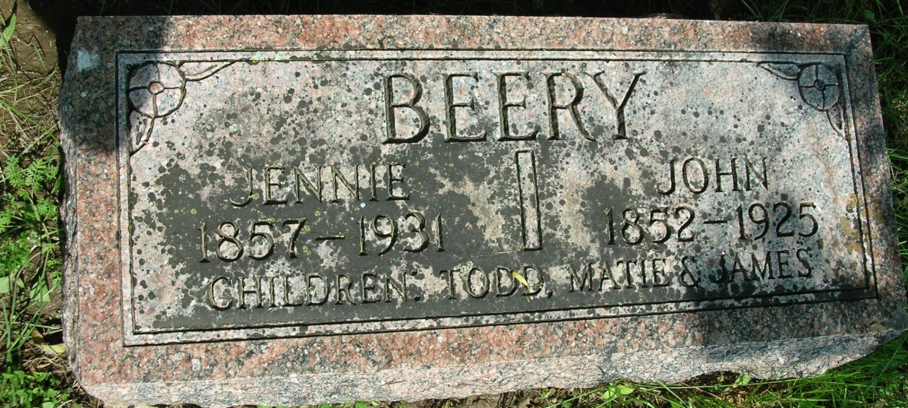

DEATH CALLS LOCAL WOMAN
Mrs. Jennie Beery, 74, Dies This Afternoon After Long Illness

Mrs. Jennie Beery, 74, for many years a well known resident of this city, died at her home, 816 Winchester Street, at 1:50 o'clock this afternoon of uremic poisoning. Mrs. Beery had suffered with cancer for several months and was bedfast the past six weeks.
She was a member of the Methodist Episcopal Church of this city. Mrs. Beery was born at Galesburg, IL, Sept. 28, 1857, the daughter of James and Liddy Barnett. Her husband, John Beery, preceded her in death six years ago.
Surviving is a daughter, Mrs. Delota Engle, at home, two sons, Paris Beery of Toledo,Ohio, and Albert Beery of this city, seven grandchildren, three brothers, Henry Barnett, Geneva, Kansas; Jerry Barnett, St Louis, Missouri; George Barnett, Washington township; three sisters, Mrs. John Stoneburner, Mrs. Addie Barnett, and Mrs. Joe Andrews all of Washington township.
Funeral services will be held Wednesday afternoon at 2:30 o'clock at the home with Rev B, H. Franklin, pastor of the Methodist Episcopal church officiating. Burial will be in the Beery cemetery, west of this city.

Contributed by mpaul21 – no source listed

