Hester Beery
October 23, 1882 – April 9, 1883

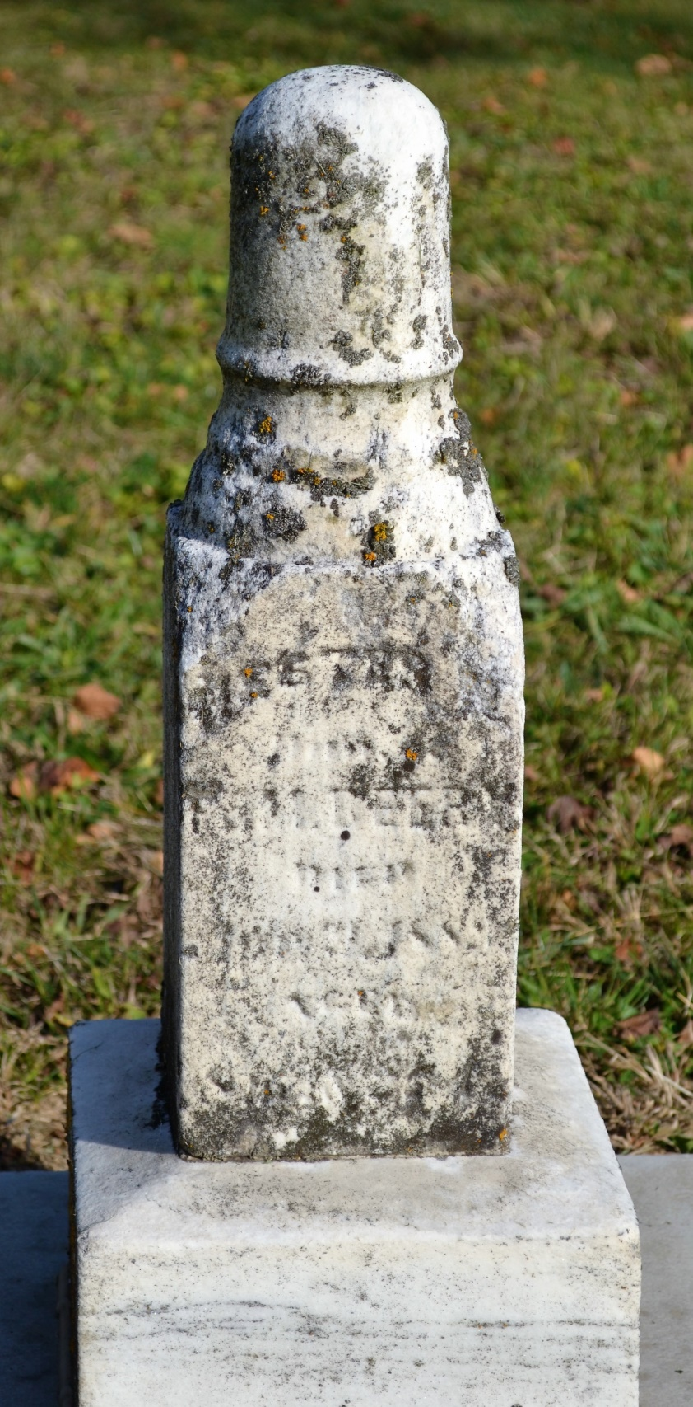
Photo by Colleen Sanders Broyles

No obit found at this time

