Cynthia A. (Farrington) Beach
November 16, 1949 – March 1, 2005

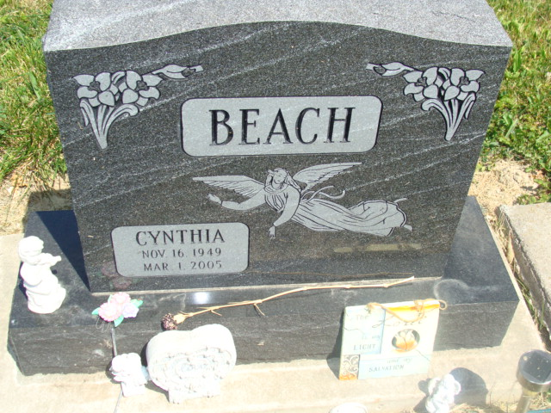
Photo by Alicia Kneuss

CYNTHIA A. BEACH, 55, of Decatur, died Tuesday, March 1, 2005. Arrangements by Zwick & Jahn Funeral Home, Decatur.

News-Sentinel, The (Fort Wayne, IN) - Thursday, March 3, 2005

Contributed by Jane Edson

*****
Indiana, Death Certificates, 1899-2011
Name: Cynthia A Beach
Gender: Female; Race: White; Age: 55; Marital Status: Divorced
Birth Date: 16 Nov 1949; Birth Place: Erie, PA
Death Date: 1 Mar 2005; Death Place: Decatur, Adams, Indiana, USA
Father: Donald Farrington; Mother: Agnes Rettger
Informant: Carla Guereca, daughter of Decatur, IN
Burial: March 4, 2005, Beery Cemetery

