Betty J. (Brown) Barton
August 28, 1924 – March 7, 1995

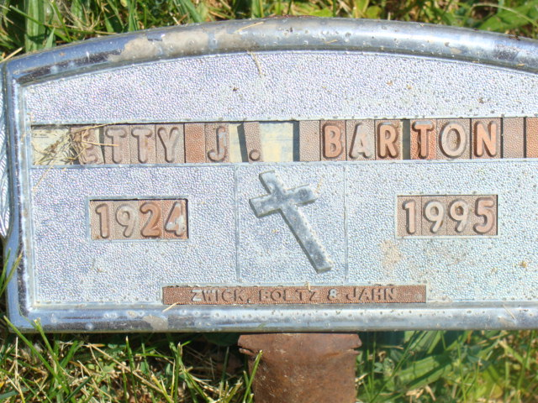
Photo by Alicia Kneuss

Decatur - Betty J. Barton, 70, died Tuesday at Lutheran Hospital, Fort Wayne. Born in Las Vegas, she was a homemaker. Her first husband, William J. Penland, died in 1960. Her second husband, Arnold J. Barton, died in 1979.
Surviving are a son, John D. Penland of Decatur; two grandchildren; three greatgrandchildren; and several brothers and sisters.
Services at 7 pm today at Zwick-Sefton & Jahn Funeral Home, Decatur. Calling from 4 to 7 pm today. Burial in Beery Cemetery, Decatur. Memorials to New Convenant Fellowship or Adams County Cancer Society.

Journal-Gazette, Allen County, IN; March 9, 1995, Page 3C

Contributed by Jim Cox

