Noah A. Baker
June 29, 1867 – February 12, 1907

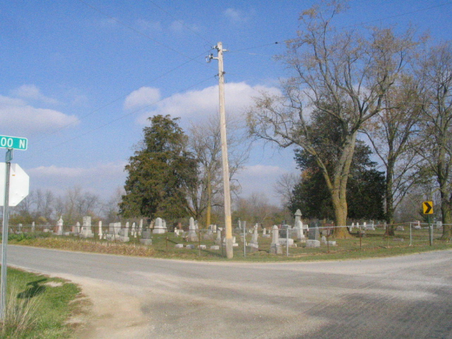
Photo by Barbara Baker Anderson

The remains of Noah Baker who died at Peabody, Kansas, will arrive this evening over the Erie from Chicago at 9:55 o'clock.
The funeral services will be held Friday afternoon at the Beery Church, at two o'clock, sun time.

Decatur Democrat, Adams County, IN; Thursday, February 14, 1907

Contributed by Karin King

