Malinda (Beery) Baker
January 13, 1843 – May 29, 1911

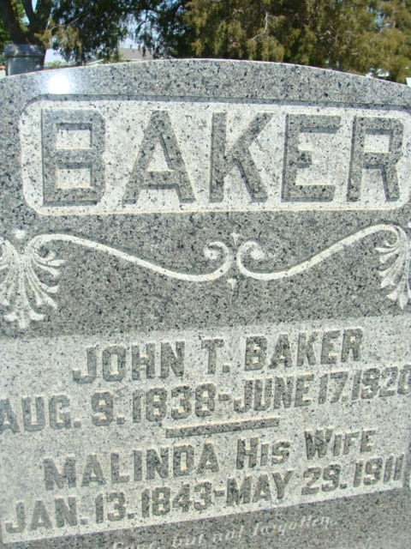
Photo by Alicia Kneuss

TO ETERNAL CITY
Was Mrs. John T. Baker, Well Known Kirkland Township Lady
CALLED LAST NIGHT
Had Been in Failing Health Since Accident A Year Ago February
In failing health since a year ago last February, when she suffered a fall down the cellar steps, sustaining a broken leg, Mrs. John T. Baker, aged sixty-eight years, one of the best known ladies of Kirkland Township, passed into eternal life at 12:30 o'clock this morning. Mrs. Baker never fully regained her strength since the accident and later complications of asthma and lung trouble arose. For several weeks she had been at the point of death, but later became better, only again to become worse until final relief at the hour stated. The maiden name of the deceased was Malinda Beery. She was the daughter of Eli and Hester Beery and was born January 13, 1843, in Fairfield County, Ohio. When but four years of age, she came with her parents to this county and settled west of this city, spending the remainder of her life in this vicinity. She was married April 15, 1860 to John T. Baker, the couple arriving at the fifty-first anniversary of their marriage last April 15th. Those who have been acquainted with Mrs. Baker say that nothing too good can be spoken of her life, as she was an ideal woman, wife and mother, a devout Christian in every respect.
The marriage was unusually happy and besides the heartbroken husband, she leaves the following grief-stricken children: Ellen, wife of B. F. Beery, of Goshen; Frank Baker, of Elkhart; Jonas E. Baker of Peabody, Kansas; Samuel Baker of Mott, N.D.; John Baker, of Houston, Texas; and Rosa, wife of Charles Andrews, who resides at the homestead. Quite recently the children from a distance were called to their mother's bedside, and were here with her for several weeks, but upon her improvement, returned again to their several vocations.
Mrs. Baker leaves the following brothers: Martin Beery of this city, Reuben, John and Chris Beery of near this city, and Dan Beery of this city. The funeral will be held Wednesday, the hour to be arranged later upon receipt of word from the children who live at a distance.
The services will be held at the Beery Church west of this city. The Rev. A. B. Yoder of Bronson, Michigan, a minister of the Mennonite Church, of which Mrs. Baker was a member before uniting with the United Brethren in Christ, and Rev. G. W. Tevis of New Carlisle, Ohio, will conduct the services.
During her declining days, Mrs. Baker made the request that should her friends desire to pay their respects to her after her death by the giving of flowers, that the floral pieces be of the white flowers only, with the green foliage as a background.

Decatur Daily Democrat, Adams County, IN; Monday, May 29, 1911

Contributed by Karin King

