Leonard Dale Arnette
September 6, 1939 – January 22, 1943

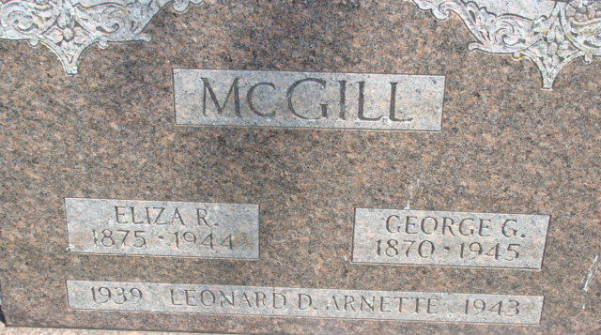
Photo by Alicia Kneuss

Leonard Dale Arnette
in the Illinois, Deaths and Stillbirths Index, 1916-1947
Name: Leonard Dale Arnette
Birth Date: 6 Sep 1939
Birth Place: Chicago, Illinois
Death Date: 20 Jan 1943
Death Place: Chicago, Cook, Illinois
Burial Date: 22 Jan 1943
Burial Place: Chicago, Cook, Illinois
Cemetery Name: Graceland
Death Age: 3
Race: White
Marital status: S
Gender: Male
Residence: Chicago, Cook, Illinois
Father Name: George Arnette
Father Birth Place: Dixon, Kentucky
Mother Name: Isabelle McGill
Mother Birth Place: Decator, Indiana
FHL Film Number: 1953844

