Noah Amspaugh
June 20, 1828 – May 26, 1893

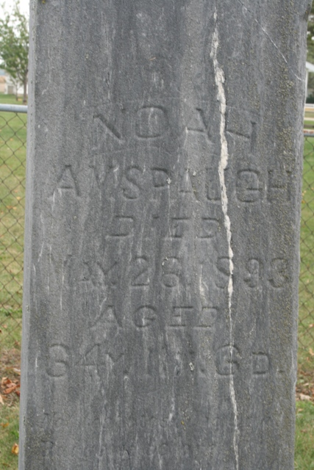
Photo by Jacquie Eisenhart
MORTUARY
Noah Amspaugh was born in Hocking County, Ohio, June 20, 1828, and died in Adams County, Indiana, May 26, 1893, aged 64 years, 11 months and 6 days. He left to mourn their loss a wife, three sons and four daughters, three brothers and four sisters; four of his children have preceded him. He was converted about twenty-two years ago and united with the church of the Brethren in Christ, and lived a constant Christian life. He bore his afflictions patiently, and said in his last hours: "Lord, I am waiting to go." He called his children to his bedside and admonished them to serve the Lord. We as Brethren will miss him, his children will miss him as a father, the widow will miss him as a husband, and he will be missed by his neighbors as a citizen.
The deceased was a member of Company I, 89th Regiment of Indiana Volunteers. He rendered three years’ service to his country.
Let all strive to live that we may meet him in the better world.
Funeral services were held at the Beery Church, of which he was a member, on Sunday, May 28, 1893, conducted by Rev. George W. Miranda, of New Carlisle, Ohio, and attended by a very large number of his neighbors and friends, who thus showed the earthly tribute of respect for a well spent life.

Decatur Democrat, Adams County, IN; Friday, June 2, 1893

Contributed by Karin King

