Hetty M. Amspaugh
November 15, 1868 – March 16, 1878

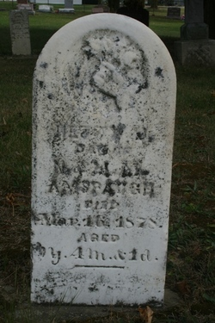
Photo by Jacquie Eisenhut

No obit found at this time

