Dorothy Jean (Mole) Alverson
1930 – August 13, 1950

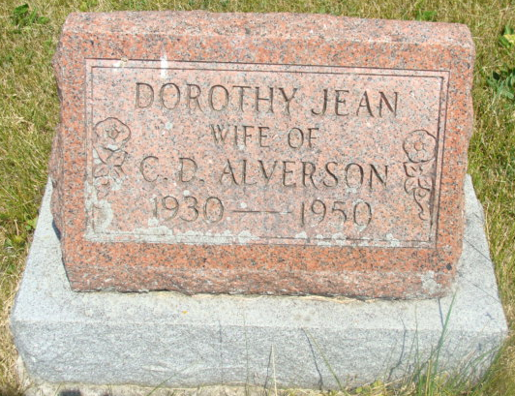
Photo by Alicia Kneuss

Mrs. Dorothy Jean Alverson, 20, of 2015 South Harrison Street, died at 9:15 am Sunday at the Robert Long Hospital, Indianapolis, following a five-year illness. Mrs. Alverson was born in Charleston, S.C.
She is survived by her husband, Clarence; one son, Brian; her mother, Mrs. Nita Mole, Summerville, S. C.; three brothers, William Mole, Charleston, Robert, Michigan, and Richard, with the US Army and three sisters, Mrs. Ethel Evans and Annette and Janette Mole, Summerville.
Services will be at 2 pm Wednesday at the Zwick Funeral Home, Decatur, the Rev. J. Carl Williams officiating. Burial will be in the Antioch Cemetery, Decatur. Friends may call at the funeral home after 2 pm today.

Journal-Gazette, Allen County, IN; Monday, August 14, 1950, Page 2

Contributed by Jim Cox
*****
Indiana, Death Certificates, 1899-2011
Name: Dorothy Jean Alverson [Dorothy Jean Mole]
Gender: Female; Race: White; Age: 20; Marital Status: Married
Birth Date: 12 May 1930; Birth Place: South Carolina
Death Date: 13 Aug 1950; Death Place: Indianapolis, Marion, Indiana, USA
Father: Kelley Mole; Mother: Neita Avant
Informant: C. D. Alverson of Fort Wayne, IN
Burial: 8/16/1950, Antiock

