Virginia C. (Schaefer) Lybarger
August 12, 1909 – November 12, 2002

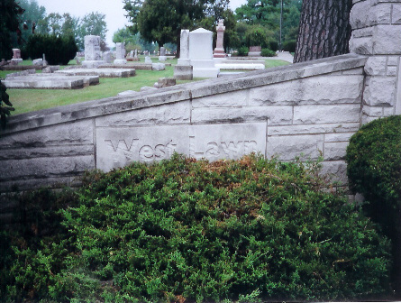
Photo by Joan Shoffner

Virginia C. Lybarger, 93, of Swiss Village in Berne, a former Geneva resident, died November 12, 2002 in Swiss Village.
She was born August 12, 1909, in Geneva to Cornelius and Lola Ford Schaefer. She married Gerald VanSkyock; he died in 1945. She later married James Lybarger; he died in 1983.
She was the first female to manage the former Kroger store in Geneva and also worked at L.S. Ayres in Fort Wayne as an assistant in its Tea Room. She was a member of High Street United Methodist Church in Geneva.
Surviving is a sister, Mrs. Lester (Harriet A.) Habegger of Fort Wayne; a stepson, John Lybarger of Churubusco; several nieces, several nephews, and several grandchildren.
Burial was in West Lawn Cemetery at Geneva.
Contributed by Jim Cox - no source listed

