Rose May (Johnson) LaRue
August 19, 1872 – December 11, 1945

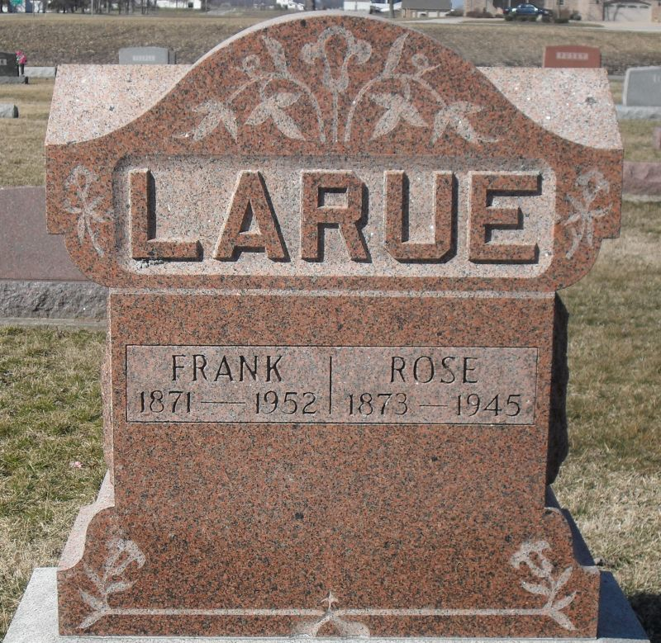
Photo by Stephen & Andrea Brangan

(Handwritten date: Wednesday, Dec. 12, 1945)

WIFE OF FRANK LARUE SUCCUMBS SUDDENLY TUES.
Funeral Friday For Sister of Rev. Frank Johnson

Mrs. Rosa Johnson LaRue, 73, wife of Frank LaRue of Geneva, died suddenly at 4:00 o'clock Tuesday afternoon at her home (cut off)
She was in usual health however, when she suddenly suffered a cerebral hemorrhage yesterday and died before medical assistance could be called.
Mrs. LaRue was born east of Berne on the farm where her brother, Rev. Frank Johnson, now resides August 19, 1872, a daughter of James and Christine Beyers Johnson. She was married to Frank LaRue on October 15, 1893. They have lived in Geneva for many years.
Surviving are the husband, a daughter Dorothy LaRue, at home, Geneva correspondent for the Berne Witness, and one brother, Rev. Frank Johnson, of east of Berne. A daughter, five sisters and two brothers preceded.
The funeral will be held Friday afternoon at 1:30 o'clock at (cut off)

Adams County Historical Museum 1933-1953 Scrapbook, Image 010
Transcribed by Karin King

