Ruth Ann (Archer) Downing
June 23, 1936 – April 19, 2017

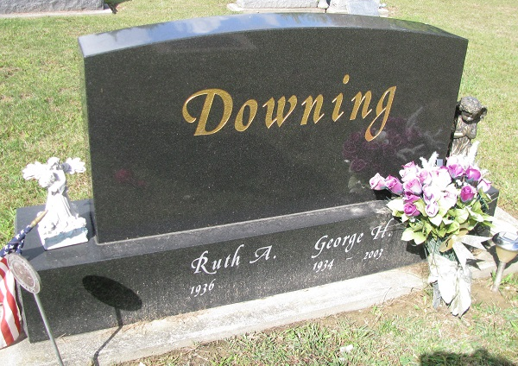
Photo by PLS

Ruth Ann (Archer) Downing, 80, Carmel, formerly of Geneva, died at 1:53
p.m. Tuesday [4/18/2017] in I.U. Health North, Carmel. Ruth was born in Vigo County on June 23, 1936, to the late John I. and Gertie M. (Smith) Archer. She was a
graduate of George Washington High School, Indianapolis. She married George H. Downing, who preceded her in death.
Together with her husband, she co-owned and operated the former Downing
Funeral Home in Geneva for 30 years. She had also worked at the Bank of Geneva. Ruth was one of those rare individuals who shared with everyone exactly what she thought, leaving little to be misinterpreted.
She is survived by her children, David Downing, Fort Wayne, and Frank (Amy) Downing, of Marion; her sister and best friend, Norma Wilson, Carmel; three grandchildren, Joshua and Caleb Downing, of Marion, and Katie Downing, of Vera Cruz.
She was preceded in death by her parents, John and Gertie Archer; husband, George Downing; sister, Juanita Neese; and brother, John Leon Archer.
Friends may call from 2 to 4 p.m. Sunday, April 22, 2017, at the Armes-Hunt Funeral Home and Cremation Services, College Park Chapel, 4601 S. Western Ave., Marion. Graveside services will be held at 10:30 a.m. Monday, April 23, in Westlawn Cemetery, Geneva, with the Rev. Paul Rogers officiating.

Downing & Glancy Funeral Home online obit (accessed 04/20/2017)

