Esther Marie (Smith) Hendricks-Strait
November 26, 1925 – September 25, 2009
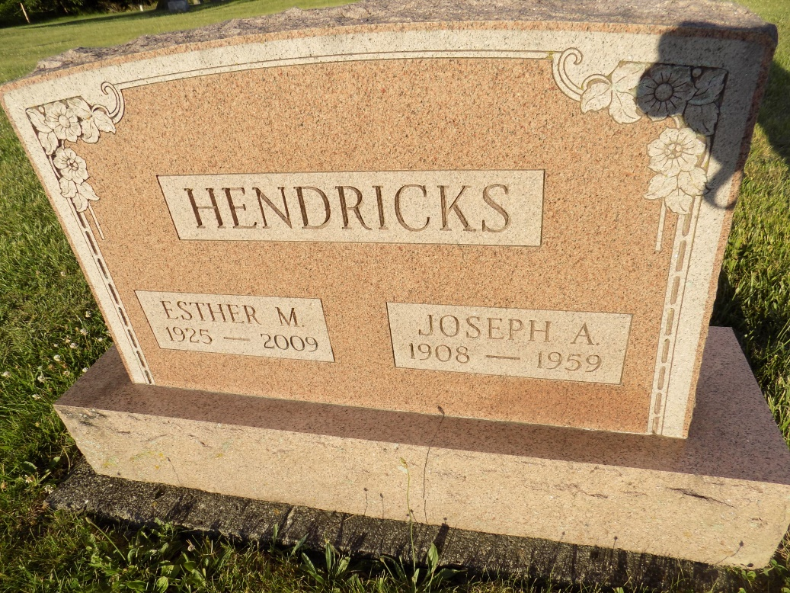
Photo by Margie Roop Pearce

Esther Marie Strait, age 83, 101 North Park Street Portland passed away Friday morning in the Ball Memorial Hospital In Muncie. She was born in Jay County November 26, 1925 the daughter of Oscar and Emma (Burkey) Smith. She was married to Joseph Hendricks who passed away and she was later married to Kenneth R. Strait and he died July 9, 1994. She was retired from Jay Garment in Portland and was a member of Salamonia Christian Church and West Walnut Street Church of Christ.
Surviving are a son Ronald Hendricks of Portland, two grandchildren and two great grandchildren.
Funeral services will be Monday at 10:00 A.M. in the Baird-Freeman Funeral Home with Pastor Jim Nichols presiding. Burial will follow in the Studebaker Cemetery in Geneva. Visitation will be Sunday from 12:00 – 3:00 P.M
Contributed by Joan Shoffner – no source listed

