William H. Blowers
February 15, 1864 – February 9, 1925

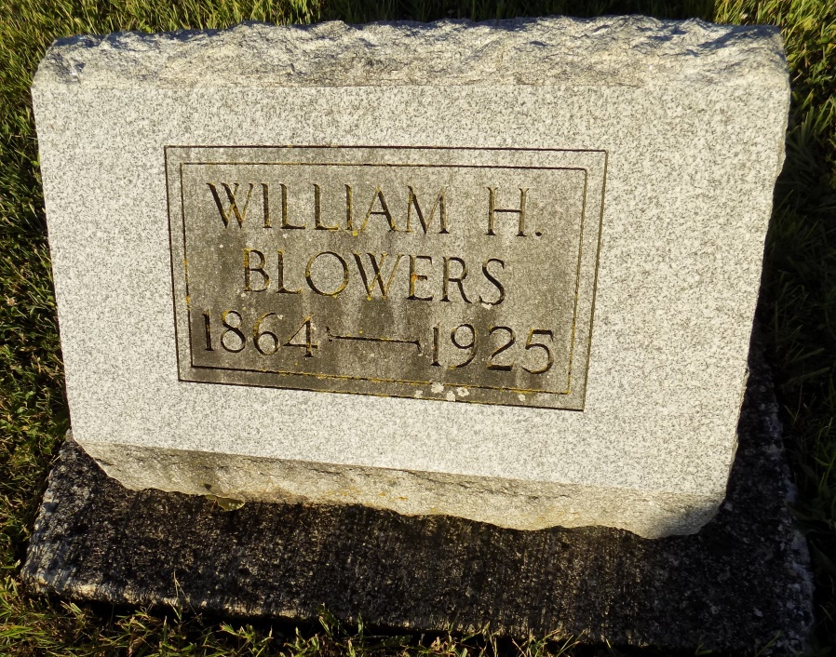

WILLIAM BLOWERS DIES AT HIS HOME IN GENEVA
Geneva, Feb. 12 - Funeral services were held from the Methodist church here at 2 o'clock this afternoon for William Blowers, age 62 years, who died at his home here following an illness of complication of diseases. Burial was made in the Studebaker cemetery.
Mr. Blowers had been blind for the last seventeen years. He is survived by his wife and a son Darrell.

Decatur Daily Democrat, Adams County, IN; Thursday, February 12, 1925
Contributed by Jim Cox

