May L. Huffman
April 18, 1914 – August 10, 1978

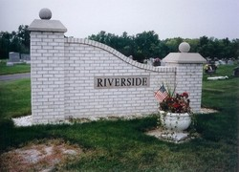

Miss May Huffman, 64, died Thursday at 10:30 in Pinehurst Nursing Home, Centerville. Miss Huffman, formerly a resident of Geneva, was born April 18, 1914 in Mount Zion. She was the daughter of William and Millie (Van Camp) Huffman.
She is survived by four sisters, Mrs. Mabel Carpenter and Mrs. Oscar (Edna) Buettner of Fort Wayne and Mrs. Gladys Cox, Richmond; and two brothers, Vern Huffman and Edward Huffman of Fort Wayne.
Services will be at 1:30 pm Saturday at the Downing Funeral Home, Rev. Charles Clark will officiate. Burial will follow at the Riverside Cemetery.
Friends and relatives may call Saturday morning after 10 am until time of the service.

Newspaper clipping from the Florence Gause Collection dated 1978

