Donald Ray Harrison
October 23, 1962 – July 15, 2019

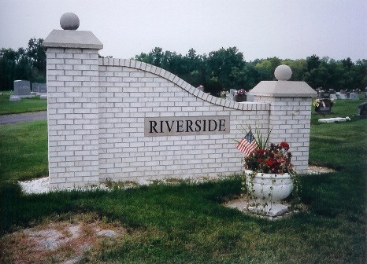
Photo by Joan Shoffner

Donald Ray Harrison, 56, of Berne, IN, passed away at 3:35 AM on Monday, July 15, 2019 at Adams Memorial Hospital in Decatur, IN. He was born on Tuesday, October 23, 1962, in Portland, IN. Donald was a 1981 graduate of South Adams High School in Berne, IN, where he was a member of the Wrestling Team. He served 13 years in the United States Navy. He was a member of the Peace Keepers Motorcycle Club and was a very proud father and grandfather and was very devoted to his family. He attended Iron Horse Fellowship Church in Chesapeake, VA and had attended Bridge Community Church in Berne, IN. Military Rites will be performed by the Berne American Legion.
Loving Survivors include his Mother - Leota Rae (Feaster) David, Berne, IN, Daughter - Sarah (Mike) Phillips, Chesapeake, VA, Brother - Jeffery Scott Harrison, Geneva, IN, Sister -Brenda Lee (Gary) Wyatt, Goodyear, AZ, Brother - Sonny Lee Harrison, Berne, IN, Sister - Tami Marie (Rex) McMillen, Decatur, IN, Granddaughter - Alexandra Bass, and several nieces and nephews.
Family and friends may gather to share and remember at Downing & Glancy Funeral Home 100 N Washington Street Geneva on Thursday, July 18, 2019 from 2:00 PM to 4:30 PM. A service to celebrate his life will be at Downing & Glancy Funeral Home, 100 N Washington Street, Geneva at 5:00 PM on Thursday, July 18, 2019 with Pastor Eric Lehman officiating. Interment will follow in the Riverside Cemetery in Geneva.
Preferred memorials may be made to funeral home for expenses.
Arrangements are being handled by Downing & Glancy Funeral Home in Geneva.

Glancy Funeral Homes, Adams County, Indiana
Tuesday, July 16, 2019

