Frank S. Fogle
November 30, 1877 – April 13, 1957

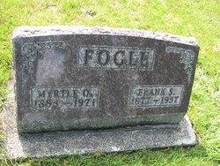
Photo by PLS

Indiana, Death Certificates, 1899-2011

Name: Frank S. Fogle
Gender: Male
Race: White
Age: 79
Marital status: Married
Birth Date: 30 Nov 1877
Birth Place: Adams CO., Indiana
Death Date: 13 Apr 1957
Death Place: New Corydon, Jay, Indiana, USA
Father: Henry Fogle
Mother: Sarah Fravel
Spouse: Myrtie Fogle, informant
Burial: 4-17-1957 Riverside near Geneva

