Pearl Selena (Reed) Brewster
September 20, 1880 – February 19, 1962

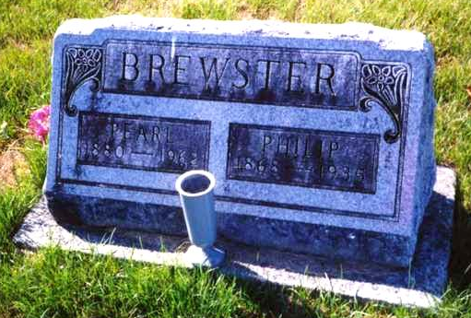
Photo by drbuck

Indiana, Death Certificates, 1899-2011

Name: Pearl Brewster
[Pearl Reid]
Gender: Female
Race: White
Age: 81
Marital status: Widowed
Birth Date: 20 Sep 1880
Birth Place: Kansas
Death Date: 19 Feb 1962
Death Place: Decatur, Adams, Indiana, USA
Father: William Reid
Mother: Emily Bryan
Informant: Dore Brewster, son, Geneva, Ind
Burial: 2-22-1962 Riverside Cemetery near Geneva

