Keith L. Brewster
February 14, 1939 – November 18, 1999

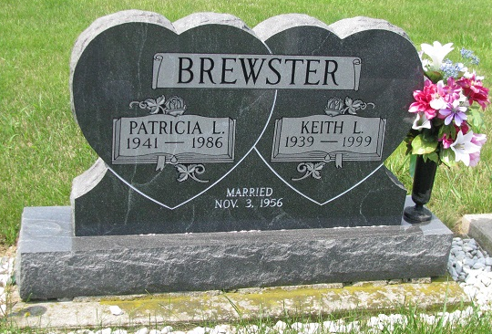
Photo by PLS
Obit from Janice Vasilovski

Keith L. Brewster, 60, of Geneva, a foreman, died Thursday, Nov. 18, 1999, at Parkview Hospital in Fort Wayne.
The Adams County native worked at Berne Furniture in Berne for 43 years and was a member of High Street United Methodist Church of Geneva.
Surviving are his wife, Maxine; a daughter, Cathy Bollenbacher of Geneva; sons Rick A. of Geneva and Brian K. of Bluffton; his mother, Hazel Brewster of Geneva; stepsons Steve Elzy of Louisville, Ky., Randy Elzy of Santa Rosa, Calif., Gary Elzy of Angola and Todd Elzy of Pleasant Mills; a brother, Jerry of Geneva; sisters Mary Robinson of Geneva, Virginia Byer of New Haven and Patty Voreis of Florida; stepsisters Ronda Dailey of Berne and Tammy Birch of Monroe; five grandchildren; and six stepgrandchildren.
He was preceded in death by his first wife, Patricia L.
Services are 10 a.m. Monday at High Street United Methodist Church, Geneva, with calling one hour before services. Calling is also from 6 to 8 p.m. today and also from 2 to 8 p.m. Sunday. Burial will be in Riverside Cemetery, Geneva. Memorials are to the Adams County Heart Fund or the Adams County Cancer Society.
Information provided by Downing Funeral Home, Geneva, 1-219-368-7676.

News-Sentinel, The (Fort Wayne, IN)
Saturday, November 20, 1999
*****

Keith L. Brewster, 60, Geneva, died at 10:01 p.m. in Parkview Memorial Hospital Thursday of injuries he suffered in a Nov. 10 traffic accident south of Monroe.
An Adams County native, Mr. Brewster was born Feb. 14, 1939, to Dore and Hazel Nussbaum-Brewster. He married Patricia Lou Black on November 3, 1956; she died November 28, 1986. He married Maxine Cook Elzey on October 1, 1988. Both his mother and his second wife survive.
Mr. Brewster was a foreman at Berne Furniture for 43 years. He was a member of the High Street United Methodist Church in Geneva.
Other survivors include a daughter, Mrs. Rodney (Cathy) Bollenbacher, Geneva; two sons, Rick A. Brewster, Geneva and Brian K. Brewster, Bluffton; a brother, Jerry Brewster, Geneva; three sisters, Mrs. Eugene (Mary) Robinson, Geneva, Mrs. Ned (Virginia) Byer, New Haven, Mrs. Richard (Patty) Voreis, Fla.; two stepsons, Steve Elzey, Louisville, Kentucky and Randy Elzey, Sanitrose, Calif.; two stepsisters, Mrs. Dewayne (Rhonda) Dailey, Berne, Mrs. Tammy Birch, Monroe; five grandchildren; and six step grandchildren.
Funeral services are at 10 a.m. Monday at High Street United Methodist Church in Geneva. Burial will take place in Riverside Cemetery, Geneva. Visiting hours are 6-8 p.m. Saturday and 2-8 p.m. Sunday at Downing Funeral Home in Geneva and one hour prior to services at the church. Memorials are to the Adams County Heart Fund.

Berne (IN) Library Heritage Room – Misc. obits
Handwritten - 1999

