Daniel M. Brewster
September 13, 1845 – May 2, 1917

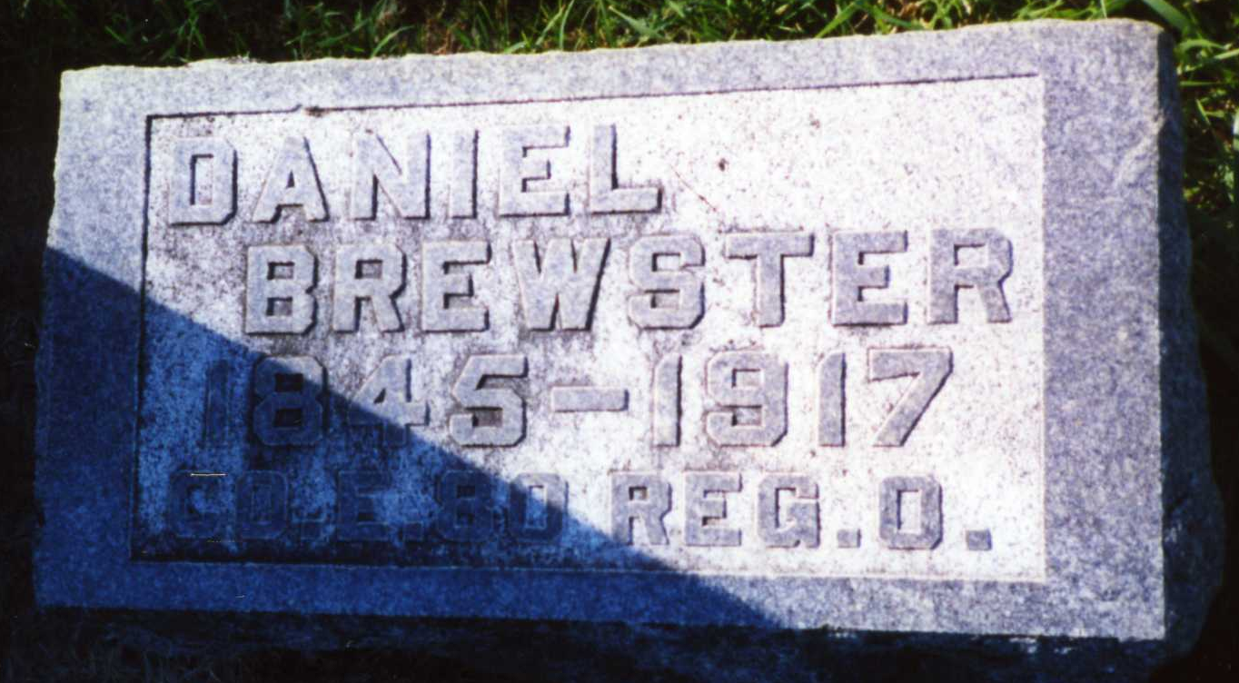
Photo by DRBuck
A VETERAN DEAD
Daniel Brewster, Resident of Jefferson Township, Died Early Today
WAS ILL LONG
Was a Veteran of the Civil War - A Well Known Man Succumbs

Daniel Brewster, aged seventy-two, long a resident of Jefferson Township, a veteran of the Civil War, died this morning about 7 o'clock, after an illness dating from last August, of a complication of diseases.
Mr. Brewster is survived by the widow, who was formerly Miss Laverta Bebout, and the following children: Frank, Fred, Mrs. Jesse Buckmaster, Mrs. Dale Rockwood and Ethel [sic], all living in the vicinity of the parental home. George and Winfield Brewster are brothers.
The deceased was well and favorably known over the country.

Decatur Daily Democrat, Adams County, Indiana
Wednesday, May 2, 1917
*****
Biography

Daniel Brewster, an energetic and persevering man whose industry and thrift have placed him among the substantial citizens of Adams county, was born in Fayette county, Pennsylvania, September 13, 1845, and is the son of Jackson and Mary (Martin) Brewster, the former a native of Fayette county, Pennsylvania, also. They were the parents of thirteen children, seven of whom reached maturity. Jackson Brewster came to Adams county in 1860 and located on a piece of land which was densely covered with timber. He at once erected a rude cabin and then settled himself to the task of clearing and rendering the ground fit for cultivation, which he successfully accomplished. In connection with agricultural pursuits he was also employed on a boat on the Ohio river prior to his coming to Indiana. When he came here wild game of all kinds was plentiful and he often saw this game in close proximity to his log cabin, while some of the meat supplied for the family was secured by means of his trusty rifle or shotgun. He died about 1894 and his wife about 1896.
The subject of this sketch passed his youthful years in much the same manner as did the average farmer boy of the locality and period, having been reared to manhood on the old homestead. When he and his father came to Jefferson township only seventy-five families lived there, of which number only one man is still living, Jacob Ryan, aged eighty-four years. Mr. Brewster is the owner of one hundred and twenty acres of land in Jefferson township and his improvements in the way of buildings, fences, etc., rank with the best in the neighborhood. In connection with his farming interests he ran a threshing machine for thirty-three years, in which business he exerted every effort to please the public. In 1864 he enlisted in the Eightieth Regiment, Ohio Volunteer Infantry, and served until the close of the war, participating in the Hood and Johnston campaign.
The subject has been twice married, his first wife being Sarah A. Fetters. They were the parents of six children: Philip, Charles, Caroline, Emma, died in 1898, and Lucinda, died June 10, 1907, and Frank. Hattie, Fred, Edna and Gusta are of the second marriage. Mr. Brewster's second marriage was with Miss Loverda Bebout, daughter of Joshua and Elizabeth (Fisher) Bebout, both natives of Pennsylvania. They are the parents of four living children, as seen above. Mr. Brewster is a staunch Republican, and has been honored by election to offices of trust and responsibility, having served as justice of the peace four years, supervisor nine years and constable four years. Fraternally he is affiliated with the Grand Army of the Republic at Geneva, Indiana , and also the Independent Order of Odd Fellows at Berne . His religious faith is that of the Evangelist church. The subject has attained success by hard work and is well entitled to the prosperity which is now his. At present he is residing on the old farm, where by honest toil and endeavor he worked his way to independence.

Snow's History of Adams County, Indiana, John Fletcher Snow, B. F. Bowen, Indianapolis, IN, 1907, p. 386 (image 791).

