Clyde C. Bradford
August 14, 1885 – December 9, 1956

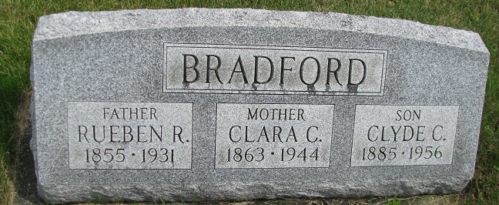
Photo by PLS

World War II Draft Registration Cards, 1942

Name: Clyde C Bradford
Gender: Male
Race: White
Birth Date: 14 Aug 1885
Birth Place: Adams, Indiana, USA
Residence Place: Geneva, Adams, Indiana, USA
Military Draft Date: 1942
Contact: W. W. Briggs, Geneva

*****
2005 Adams County (IN) Death Index

Name: Clyde C. Bradford
Birth Date: 8/14/1885
Residence: Geneva, Adams, IN
Death Date: 12/9/1956
Death Place: Geneva, Adams, IN
Burial Place: Riverside Cemetery

