Albert “Sam” Bixler
September 13, 1898 – March 16, 1975

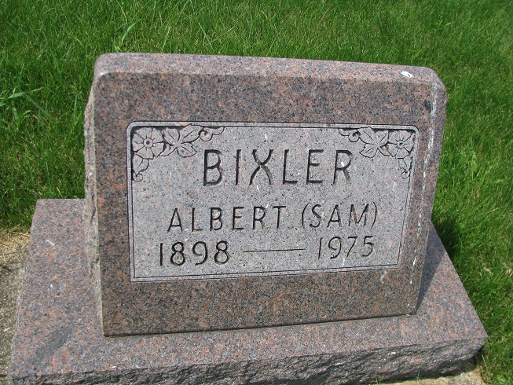
Photo by PLS

Albert (Sammy) Bixler, 77, of Geneva, a lifelong resident of Adams county, was found dead in his home early Sunday morning. A verdict of suicide by hanging was returned.
He was employed 40 years at Meshberger Brothers Stone Co., located west of Berne. Mr. Bixler was sexton of Riverside cemetery, Geneva.
Born in Wabash township on Sept. 13, 1898, he was a son of Solomon and Elizabeth Depp-Bixler.
Surviving are three brothers, Edwin of Berne; Walter of St. Petersburg of Florida and George of Fort Wayne.
Funeral services will be held Wednesday at 10 a.m. at the Yager funeral home, with Rev. Wilson Bixler officiating. Burial will be in Riverside cemetery. Friends may call at the funeral home after 7 p.m. Tuesday.

Decatur Daily Democrat, Adams County, IN Monday, March 17, 1975

Contributed by Janice Vasilovski

