Cinda Beerbower
1866 – May 4, 1952

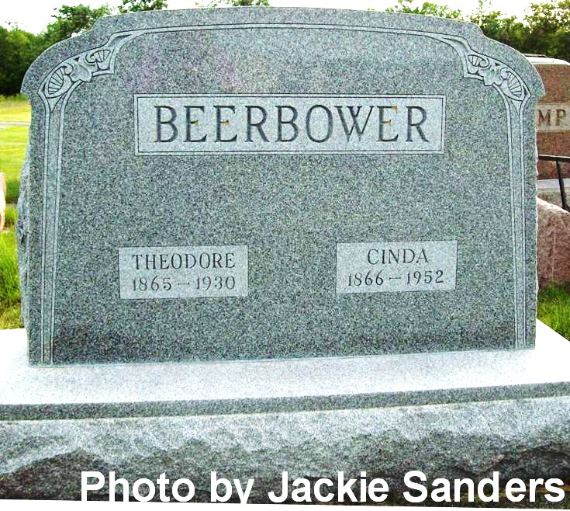

CINDA BEERBOWER DIES ON SUNDAY
Funeral Wednesday For Native Of This Community

Mrs. Cinda Beerbower, 86, widow of Theodore Beerbower, died at 4:10 p.m. Sunday at the home of her son, Russell Beerbower, Engle Road, Fort Wayne. She had been ill for several weeks. Mrs. Beerbower was a native and former resident of this community. She was formerly Cinda Heinbarger.
The body was removed to the D. O. McComb Funeral Home in Fort Wayne and will be returned to the residence at 7 p.m. today.
Surviving besides her son Russell, with whom she made her home, are another son, Lloyd Beerbower, Lima, Ohio, a brother, Erin Heinbarger, Decatur; seven grandchildren and three great-grandchildren.
Funeral services will be held Wednesday at 2 p.m. at the First Missionary church in Fort Wayne, the Rev. Clayton Steiner officiating. Burial will be in Riverside Cemetery, Geneva.
The body will be removed to the church at noon Wednesday to lie in state until the hour of service.

Berne Witness, Adams County, Indiana; Monday, May 5, 1952

Contributed by Karin King

