Ernest “Curly” Baker
September 16, 1911 – August 18, 1995

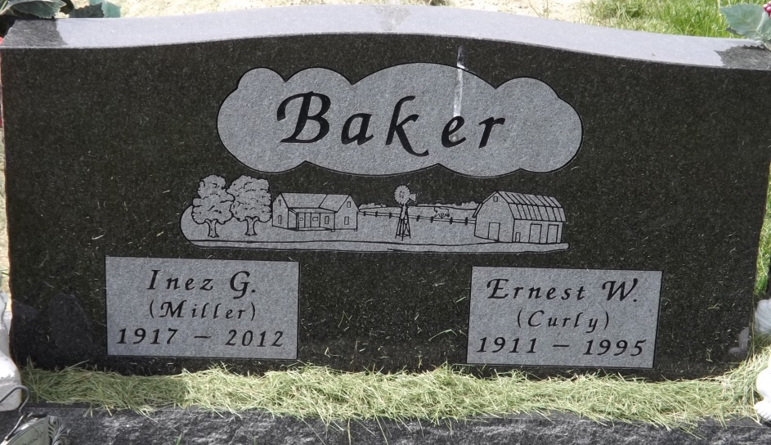
Photo by Jim Allen

Ernest “Curly” Baker, 83, of Struble Road, Rockford, OH, died 8:20 pm Friday August 18, 1995 at the Van Wert Nursing Home. He was born September 16, 1911, in Liberty Twp., Mercer County, OH, the son of Jacob A. and Catherine (Linn) Baker. He was a farmer and had retired from CTS in Berne in 1978.
He married the former Inez Miller on June 6, 1932, who survives.
Other survivors include 2 sons, Walter Baker and Bob Baker, both of Rockford, OH; 2 daughters, Mrs. Glen (Sharon) Boyse, Montpelier, IN and Mrs. Don (Nancy) Bates, Rockford, OH; 2 sisters, Marguerite Baker, Celina OH and Mrs. Robert (Genive) Mousleau, Delton, MI; 14 grandchildren, 15 great-grandchildren and 2 great-great grandchildren. Two brothers, Edgar and Victor Baker, and a sister, Delores Palmer, preceded him in death.
Services are 10:30 am (Ohio time) Tuesday, August 22, 1995 at St. Paul’s United Church of Christ, Rockford, OH. Rev. John Fleming will officiate and burial will be in Riverside Cemetery, Geneva.
Memorials to Mercer County Visiting Nurses.

Berne (IN) Library Heritage Room
Misc. Death Book BB

