Donna Jean (Brough) Bailey
September 4, 1930 – October 10, 1963

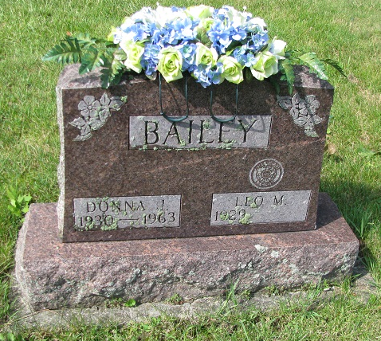
Photo by PLS

Mrs. Donna Bailey Dies This Morning

Mrs. Donna Jean Bailey, 33, wife of Leo Bailey of Ceylon, died at 1:15 a.m. today at the Clinic hospital in Bluffton. She had been ill with acute leukemia for 10 years and in serious condition for two weeks.
Born Sept. 4, 1930 in Grand Rapid, Mich., she was a daughter of Fred M. and Ethel Welch-Brough, and was married at Pleasant Mills March 25, 1949, to Leo Bailey.
Mrs. Bailey was employed at the Berne Overall and Shirt Co.
Surviving are her husband; her parents, who also reside at Ceylon; one daughter, Beverly Kay at home, and three sisters, Mrs. William (Muriel) Bailey of Geneva route 2; Mrs. Clyde (Eloise) Hamrick of Decatur route 6, and Mrs. Pete (Virginia) Girod of Monroe route 1. A brother, Frederick, was killed in a boating accident in 1953.
Funeral services will be held at 1:30 p.m. Saturday at the Yager funeral home in Berne, the Rev. Orin Daniels officiating. Burial will be in Riverside cemetery, east of Geneva. Friends may call at the funeral home after 12 noon Friday.
(Thurs. Oct. 10, 1963)

Berne (IN) Library Heritage Room
Adams County Obits 1962 – 1964
Transcribed by Janice Vasilovski

