Gorman C. Augsburger
December 28, 1911 – March 8, 2004

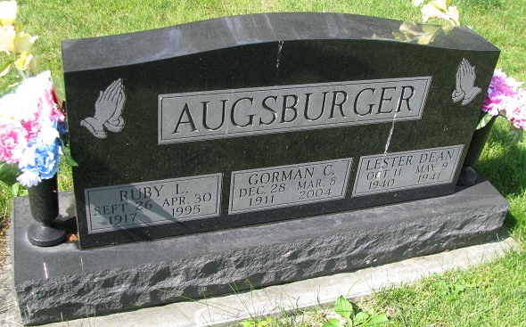
Photo by PLS

Gorman C. Augsburger, 92
A resident of Swiss Village Retirement Center, Gorman C. Augsburger, 92, died at Swiss Village at 8:50 a.m. Monday, March 8.
Born Dec. 28, 1911 to Eli and Emma Wanner Augsburger, he married the former Ruby Nelson in Adams County March 12, 1938. She preceded him in death April 30, 1995.
A farmer in Wabash and Hartford Twps. in Adams County, he served as groundskeeper for the Wabash Valley Golf Course for several years. He was a member of the High Street United Methodist Church in Geneva.
Survivors include two sons, two daughters, 11 grandchildren and 18 great-grandchildren.
( additional survivor information may be found in the original obituary.) Two sons, Leonard and Lester Augsburger preceded him in death.
Services at Downing & Glancy Funeral Home in Geneva will be held at 10:30 a.m. Thursday. Rev. Edwin L. Clark will officiate and burial will be at Riverside Cemetery in Geneva. Calling hours are from 2 to 8 p.m. Wednesday at the funeral home. Memorials may be made to the donor’s choice.

Bluffton News Banner, Wells County, Indiana
March 9, 2004
*****
BERNE - Gorman C. Augsburger, 92, died Monday in Swiss Village Retirement Center.
The Adams County native had farmed in Hartford and Wabash townships and was the groundskeeper for Wabash Valley Golf Course, Geneva, for many years.
Surviving are children, Melvin, Berne, Joan Morgan and Jean Moore, both of Geneva, and Max, Florida.

Services are at 10:30 a.m. Thursday in Downing & Glancy Funeral Home, 100 N. Washington St., Geneva. Burial is in Riverside Cemetery, Geneva. Visitation is from 2-8 p.m. today at the funeral home. Memorials may be made to the donor's choice.

Chronicle-Tribune (Marion, IN)
Wednesday, March 10, 2004

