William A. Aspy
February 9, 1859 – May 30, 1921

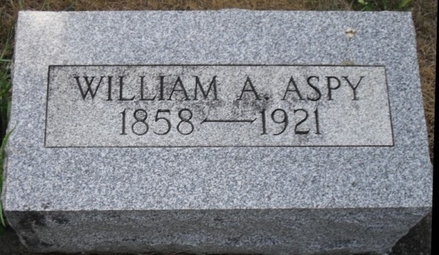
Photo by Stephen & Andrea Brangan

Indiana, Death Certificates, 1899-2011

Name: William A Aspy
Gender: Male
Race: White
Age: 62y, 3m, 21d
Marital status: Married
Birth Date: 9 Feb 1859 (based on age at time of death)
Birth Place: Indiana
Death Date: 30 May 1921
Death Place: Wabash, Adams, Indiana, USA
Father: Mark Aspy
Mother: Elsie Aspy
Spouse: Nettie Aspy, informant
Burial: 6-2-1921 Riverside Cemetery

