Charles F. Aspy
May 5, 1918 – December 16, 1990

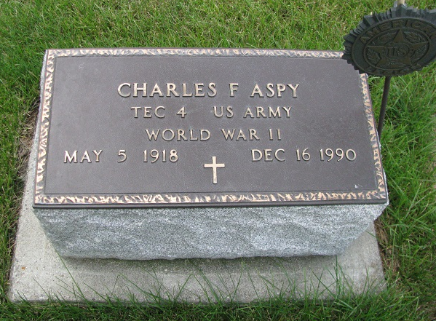
Photo by PLS

Indiana, Death Certificates, 1899-2011

Name: Charles F Aspy
Gender: Male
Race: White
Age: 72
Marital status: Never Married (Single)
Birth Date: 5 May 1918
Birth Place: Geneva Indiana
Death Date: 16 Dec 1990
Death Place: Portland, Jay, Indiana, USA
Father: Floyd Aspy
Mother: Katherine Cook
Informant: Robert Aspy, brother
Burial: Dec 19, 1990 - Riverside Cemetery, Geneva

