Janie (Irwin) Arnold
September 21, 1897 – October 5, 2003

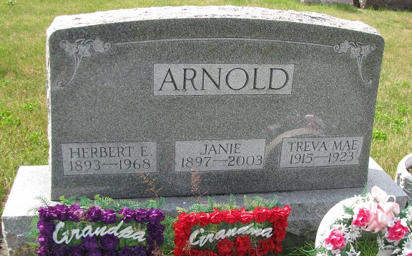
Photo by PLS
Obit from Karin King

Janie Arnold, 106
A lifelong resident of Adams County, Janie Arnold, 106, died at 11 p.m. Sunday, Oct. 5 at Chalet Village Health Care Center in Berne.
A homemaker all of her life, she also was a member of the Hartford Township Home Ec club in Adams County and attended the High Street United Methodist Church in Geneva. She had been a resident of Chalet Village the past five years. She attended Jefferson Township High School in Adams County.
Born Sept. 21, 1897 in Jefferson Twp. to Phillip and Lurena Pearl Dailey Irwin, her marriage on June 26, 1915 was to Herbert E. Arnold, who died Jan 2, 1968.
Survivors include a son, Kenneth Arnold and a daughter, Thelma Fellers, both of Geneva; 12 grandchildren, 39 great-grandchildren, 37 great-great-grandchildren and three great-great-great-grandchildren.
She was preceded in death by two daughters, nine brothers and sisters, a grandson and a great-grandson.
Services will be held at 2 p.m. Wednesday at Downing & Glancy Funeral Home in Geneva with calling today from 2 to 8 pm. Rev. Edwin L. Clark will officiate at services and burial will be in Riverside Cemetery in Geneva.
Preferred memorials to Family Hospice of Northeast Indiana.

Bluffton News Banner, Wells County, Indiana
Oct. 7, 2003

