James H. Armstrong
1863 – November 26, 1945

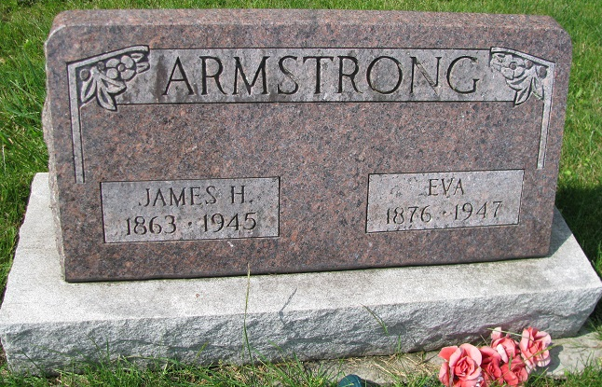
Photo by PLS

Indiana, Death Certificates, 1899-2011

Name: James Armstrong
Gender: Male
Race: White
Age: 81y, 2m, 7d
Marital status: Married
Birth Date: 12 Nov 1863
Death Date: 29 Nov 1945
Death Place: Geneva, Indiana, USA
Father: Steven Armstrong
Mother: Marian Nelson
Spouse: Eva Armstrong, informant
Burial: no date, Riverside Cemetery, Geneva

