Chester David Armstrong
June 18, 1898 – March 21, 1968

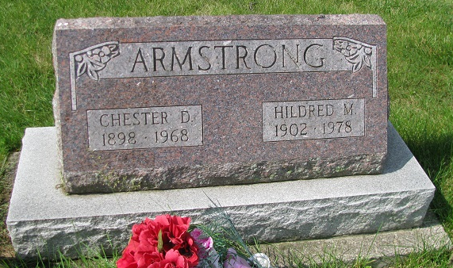
Photo by PLS

Indiana, Death Certificates, 1899-2011

Name: Chester David Armstrong
Gender: Male
Race: White
Age: 69
Marital status: Married
Birth Date: 18 Jun 1898
Birth Place: Indiana
Death Date: 21 Mar 1968
Death Place: Decatur, Adams, Indiana, USA
Father: James H Armstrong
Mother: Eva Beeler
Spouse: Hildred Runyon
Informant: Hildred Armstrong, wife
Burial: 3-24-1968, Riverside near Geneva

