Zilla L. Sprunger
March 5, 1885 – May 11, 1978

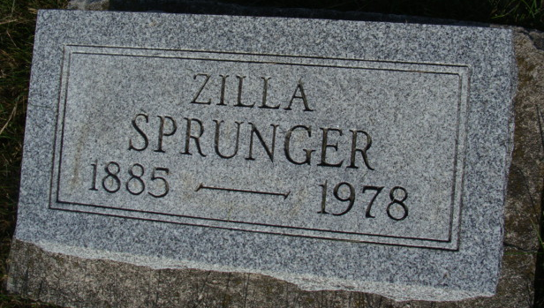
Photo by Alicia Kneuss

Zilla Springer
in the Indiana, U.S., Death Certificates, 1899-2011
Name: Zilla Springer
[Zilla Sprunger]
Gender: Female
Race: White
Age: 93
Marital status: Single
Birth Date: 5 Mar 1885
Birth Place: Indiana
Death Date: 11 May 1978
Death Place: Wabash, Wabash, Indiana, USA
Father: Stephen Sprunger
Mother: Anna Liechty
Informant: Dorothy Parson; adm., Manchester, Indiana
Burial: May 13, 1978; MRE Cemetery; Berne, Indiana

