Zilla Sprunger
December 27, 1889 – May 4, 1982

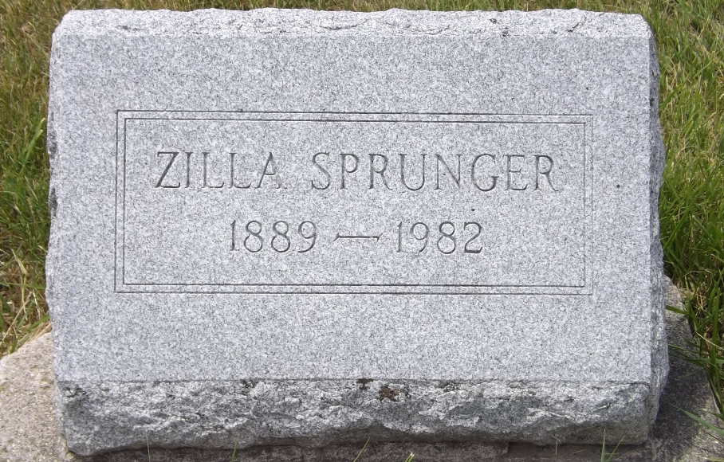
Photo by Jim Allen

Zilla Sprunger, 92, Swiss Village, Berne, died Tuesday at 7:07 p.m. at her residence. She was a member of the First Mennonite Church, Berne. She was a retired employee of the Winner House in Berne. Born on Dec. 27, 1889, in Adams County, she was the daughter of Emanuel and Katherine Stauffer-Sprunger, and was never married.
Survivors include one brother, Silvan Sprunger, Berne, and a foster sister, Mrs. Paul (Sarah) Liechty, Rt. 2, Berne.
Services will be held at 10 a.m. Friday in the First Mennonite Church Chapel, with Rev. Curt A. Claassen officiating. Burial will be in the MRE Cemetery. Memorials are to the General Conference of the Mennonite Church. Friends may call at the Yager Funeral Home after 2 p.m. Thursday.

Decatur Daily Democrat, Adams County, Indiana
Wednesday, May 5, 1982

