William J. Sprunger
October 18, 1867 – July 21, 1932

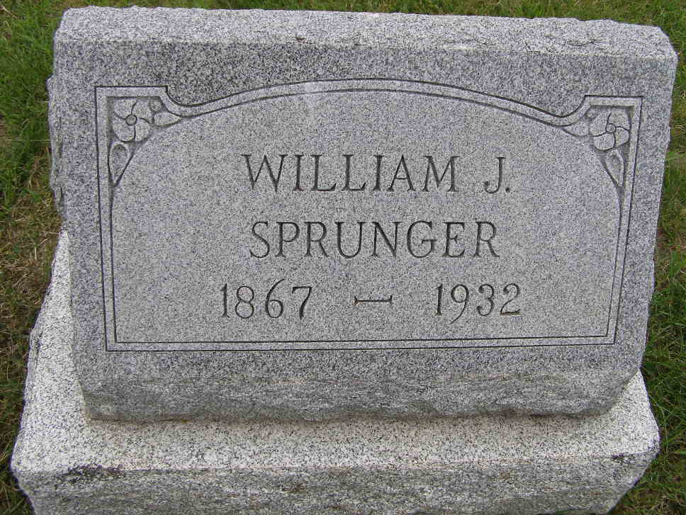
Photo by Shaunda Bedwell Opdycke

DEATH TAKES W. J. SPRUNGER THIS FORENOON
Local Music Store Proprietor Expires at Isaac Lehman Home
BEDFAST SINCE LAST MONDAY

William J. Sprunger, 64, of this place, died this forenoon at 10:15 o'clock at the home of Isaac Lehman on Indiana street, where he had made his home for several years. Mr. Sprunger, former well-known business man, had been bedfast since Monday. He suffered from a general run-down condition and had been in poor health for several years. He made his last visit uptown last Saturday.
Mr. Sprunger formerly operated the music store and still was owner of the building in which the Music Store and Samuel Liechty's jewelry store are located. He was unable to personally attend to his business during the past several years and left it in charge of Miss Sybilla Sprunger. He was well versed in musical instruments and had devoted most of his life to them. He was one of the organizers of the Mennonite male chorus and sang in the group for many years.
The deceased was born near Berne, October 18, 1867, a son of Peter and Catharine Amstutz Sprunger. His mother died when he was a young lad (cut off)
...Mr. and Mrs. Isaac Lehman since October 27, 1924. He was never married.
His parents both preceded him in death. Surviving are his step-mother, Mrs. Catharine Sprunger of Berne and the following half-sisters and half-brothers: Mrs. Ben Flueckiger, of this community; Reuben, Jerry and Elmer Sprunger of Montana; Mrs. David Lehman, Orrville, O.; Abraham Sprunger, Lima, O.; Jonas Sprunger and Mrs. Arman Habegger, both of near here; Mrs. Elmer Luginbill and Calvin Sprunger of this place and Mildred, at home with her mother. One full sister, Dinah, preceded him and two half-sisters and one half-brother, Anna Elizabeth, Rosina and Ernest.
The deceased was a member of the Mennonite church for many years.
Funeral services will be held at 1:30 o'clock Saturday afternoon at the house, and at 2:00 at the First Mennonite church here, Rev. C. H. Suckau officiating. Interment will be in the M.R.E. cemetery.

Adams County (IN) Historical Museum
1935 Scrapbook, image 30
Handwritten date: Thursday, July 21, 1932
**

Indiana, U.S., Death Certificates, 1899-2017

Name William J. Springer
Gender Male
Race White
Marital Status Single
Age 64y 9m 3d
Birth Date 18 Oct 1867
Birth Place Indiana
Death Date 21 Jul 1932
Death Place Berne, Adams, Indiana, USA
Death Registration Date 1932
Father Peter A. Springer b. Switzerland
Mother Anna Amstutz b. Switzerland
Informant Jonas Sprunger, Berne, IN
Burial M.R.E. Cemetery 7-23-1932

