Willard F. Sprunger
December 10, 1908 – October 10, 1993

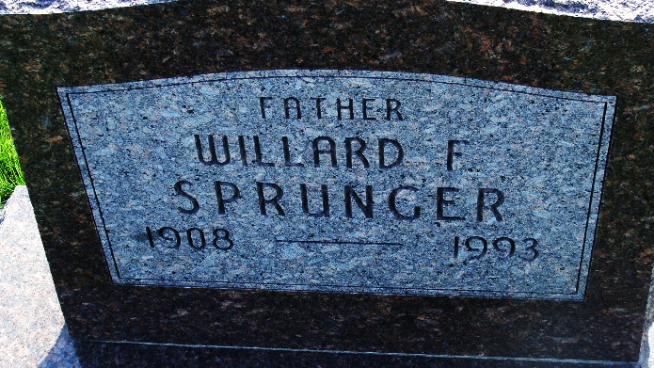
Photo by Alicia Kneuss

WILLARD "BILL" SPRUNGER, 84, of Berne died yesterday in Swiss Village. The Adams County native retired from General Electric Co. in DeKalb, Ill., in 1974 after 31 years. Surviving are a sister, Verena Springer of Berne, and brother, Sherwood S. of Alexandria, Va. Services are 10:30 a.m. tomorrow in First Mennonite Church, Berne, with burial in MRE Cemetery. Calling is 3:30 to 8 p.m. today in Yager-Kirchhofer Funeral Home, Berne, and 9:30 to 10:30 a.m. tomorrow in the church.

News-Sentinel, The (Allen County, Indiana)
Monday, October 11, 1993
**
WILLARD SPRUNGER
Willard F. "Bill" Sprunger, 64, of Berne, died Sunday in Swiss Village Retirement Center, his residence since January of 1987. He was born on December 10, 1908 in Adams County to Theodore and Rosina Nussbaum Sprunger and retired in December, 1974 after a 31-year career as a methods and standards technician at the DeKalb, Illinois General Electric Co. plant. He was a member of Berne's First Mennonite Church.
Surviving are a sister, Mrs. Gordon (Verena) Sprunger, Berne, and a brother, Sherwood S. Sprunger, Alexandria, Virginia. A son, Barry Sprunger, and a brother, Marion K. Sprunger, are deceased.
Funeral services will be at 10:30 a.m. Tuesday in the chapel of First Mennonite Church, Revs. Curt Claassen and Steven Sprunger officiating. Burial will be in MRE Cemetery, Berne. Visiting hours are 3:30 - 8 p.m. today in Yager-Kirchhofer Funeral Home, Berne, and 9:30 - 10:30 a.m. Tuesday in the church. Preferred memorials are to Swiss Village.
Decatur Daily Democrat, Adams County, Indiana
Monday, October 11, 1993

